* Copyright for test papers and marking guides remains with *West Australian Test Papers*.
* The papers may only be reproduced within the purchasing school according to the advertised conditions of sale.
* Test papers must be withdrawn after use and stored securely in the school until Friday 11th June, 2021.



**HUMAN BIOLOGY**

**Semester 1**

**2021**

Name: Marking Key

Teacher: ___________________________________________________

**Time allowed for this paper**

Reading time before commencing work: ten minutes

Working time: two hours and thirty minutes

**Materials required/recommended for this paper**

***To be provided by the supervisor***

This Question/Answer booklet

Multiple-choice answer sheet

***To be provided by the candidate***

Standard items: pens (blue/black preferred), pencils (including coloured), sharpener, correction fluid/tape, eraser, ruler, highlighters

Special items: up to three calculators, which do not have the capacity to create or store programmes or text, are permitted in this ATAR course examination

**Important note to candidates**

No other items may be taken into the examination room. It is **your** responsibility to ensure that you do not have any unauthorised material. If you have any unauthorised material with you, hand it to the supervisor **before** reading any further.

**Structure of this paper**

|  |  |  |  |  |  |
| --- | --- | --- | --- | --- | --- |
| Section | Number of questions available | Number of questions to be attempted | Suggested working time (minutes) | Marks available | Percentage of examination |
| Section One  Multiple-choice | 30 | 30 | 40 | 30 | 30 |
| Section Two  Short answer | 8 | 8 | 70 | 100 | 50 |
| Section Three  Extended answer | 3 | 2 | 40 | 40 | 20 |
|  |  |  |  | **Total** | 100 |

**Instructions to candidates**

1. The rules for the conduct of the Western Australian external examinations are detailed in the *Year 12 Information Handbook 2021*. Sitting this examination implies that you agree to abide by these rules.

2. Write your answers in this Question/Answer booklet preferably using a blue/black pen. Do not use erasable or gel pens.

3. Answer the questions according to the following instructions.

Section One: Answer all questions on the separate Multiple-choice answer sheet provided. For each question, shade the box to indicate your answer. Use only a blue or black pen to shade the boxes. Do not use erasable or gel pens. If you make a mistake, place a cross through that square, then shade your new answer. Do not erase or use correction fluid/tape. Marks will not be deducted for incorrect answers. No marks will be given if more than one answer is completed for any question.

Section Two: Write your answers in this Question/Answer booklet. Wherever possible, confine your answers to the line spaces provided.

Section Three: Consists of three (3) questions. You must answer any two (2) questions. Tick the box next to the question you are answering. Write your answers in this Question/Answer booklet.

4. You must be careful to confine your answers to the specific questions asked and to follow any instructions that are specific to a particular question.

5. Supplementary pages for planning/continuing your answers to questions are provided at the end of this Question/Answer booklet. If you use these pages to continue an answer, indicate at the original answer where the answer is continued, i.e. give the page number.

**Section One: Multiple-choice 30% (30 Marks)**

This section has **30** questions. Answer **all** questions on the separate Multiple-choice answer sheet provided. For each question shade the box to indicate your answer. Use only a blue or black pen to shade the boxes. Do not use erasable or gel pens. If you make a mistake, place a cross through that square, then shade your new answer. Do not erase or use correction fluid/tape. Marks will not be deducted for incorrect answers. No marks will be given if more than one answer is completed for any question.

Suggested working time: 40 minutes.

1. Substances that can move directly through the phospholipid bilayer through simple diffusion include
   1. sodium ions.
   2. glucose molecules.
   3. **oxygen molecules.**
   4. ribonucleic acid.

Use the diagram of the phospholipid bilayer below to answer the questions 2-4.

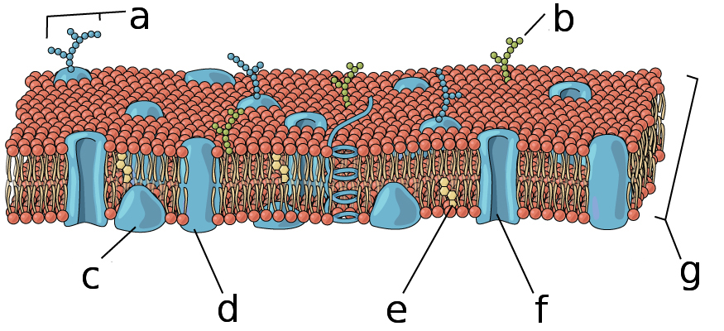

1. Which letter represents a peripheral protein?
   1. A
   2. B
   3. **C**
   4. D
2. Which letter represents cholesterol?
   1. D
   2. **E**
   3. F
   4. G
3. What structure is used to transport substances via facilitated diffusion?
   1. D
   2. E
   3. **F**
   4. G
4. As a cells size increases, the surface area to volume ratio
   1. decreases, causing rapid heat loss.
   2. increases, causing rapid heat loss.
   3. increases, causing difficulty in obtaining cell requirements.
   4. **decreases, causing difficulty in obtaining cell requirements.**
5. The test for Covid-19 analyses samples for the presence of antibodies in the body. The cells, which produce these antibodies and act to protect the body from foreign invaders, are known as
   1. thrombocytes.
   2. erythrocytes.
   3. platelets.
   4. **leucocytes.**
6. Sebaceous glands in our skin secrete an oily substance known as sebum that contains lipids. Which cell organelle would you expect to find in high numbers within the cells of these glands?
7. Ribosomes
8. Mitochondria
9. **Smooth endoplasmic reticulum**
10. Golgi body
11. The two sets of convolutions in the nephron allows for
12. decreased concentration gradients for better reabsorption.
13. **an increase in surface area for reabsorption and secretion.**
14. a rise in blood pressure for increased filtration.
15. minimal loss of filtrate during urine production.
16. The function of the cilia found in the epithelial cells of the trachea is to help move
17. **mucus and debris out of the lungs.**
18. air into the bronchioles.
19. mucus into the lower respiratory tracts.
20. air out of the mouth and nose.

Question 10 refers to the following graph showing the activity of an enzyme over a range of temperatures.

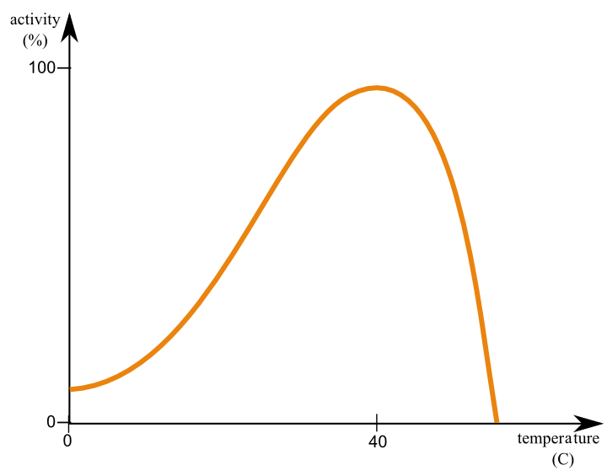

1. Which of the following explains the reduction in enzyme activity in the graph shown above?
2. Action of inhibitors increases
3. Substrates begin to break down
4. **Active site changes shape**
5. Product concentration increases
6. During a scientific investigation, several trials are run. Which of the following is the best reason to explain this?
7. Increase validity
8. **Reduce effect of random errors**
9. For the scientist to improve their skills
10. Increase accuracy
11. A typical pair of adult human lungs contains 480 million alveoli. The reason for this high number is to:
12. **increase surface area for gas exchange.**
13. increase the number of muscles to breath.
14. maintain the shape and keep the lungs inflated.
15. decrease pressure allowing air to be inspired.
16. Familial hypercholesteremia results from the failure of specific receptors on the cell membrane. The receptors allow low-density lipoproteins to be engulfed and ultimately lowers blood cholesterol levels. Patients suffering this genetic disorder are at risk of cardiovascular disease. The movement of these lipoproteins into the cells is best known as:
17. facilitated transport.
18. exocytosis.
19. active transport.
20. **endocytosis**.
21. The enzyme found in the human mouth starts the digestion of carbohydrates. Which of the following correctly identifies the name and optimal pH for this enzyme?
22. Amylase; pH 5
23. Maltase; pH 9
24. **Amylase; pH 7**
25. Maltase; pH 5

Questions 15 and 16 refer to the diagram below that shows the different organs associated with the digestive system.

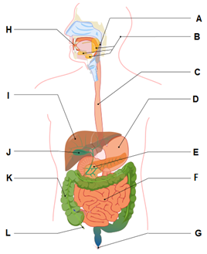

1. Achlorhydria is an autoimmune disease that damage mucosa cells and can cause impaired digestion of food. In which organ would these cells be found?
2. Organ C
3. **Organ D**
4. Organ E
5. Organ J
6. Which of the following is **not** a function of the organ labelled K?
7. Absorption of water and vitamins
8. Formation and storage of faeces
9. Breakdown of organic matter
10. **Production of enzymes for chemical digestion**
11. Which of the following statements **correctly** identifies the difference between elimination and excretion?
12. Excretion occurs mainly through faeces, whilst elimination occurs through urine.
13. Excretion removes indigestible material, whilst elimination removes metabolic wastes only.
14. Elimination occurs in several different organs, whilst excretion occurs only in the kidneys.
15. **Elimination is the removal of indigestible material and metabolic waste, whilst excretion removes metabolic wastes only.**
16. A student used a 10X ocular lens and a 40X objective lens to view a sample of tissue. A field of view of 300μm was measured. When the objective lens was changed to 10X, what would be the new field of view?
17. **1.2 mm**
18. 7.5 mm
19. 120 μm
20. 75 μm
21. Coenzyme Q10 is required for the synthesis of adenosine triphosphate. Which of the following **best** explains how a coenzyme works?
22. Small organic and inorganic molecules that bind to the enzyme and change the shape of the active site.
23. Large protein molecules that permanently bind to enzymes and act as catalysts.
24. **Organic molecules that temporarily bind to an enzyme and change their shape.**
25. Inorganic molecules that produce chemical reactions between enzymes and substrates.
26. Compared to inhaled air, exhaled air should have a higher percentage of
27. nitrogen and oxygen.
28. carbon dioxide and nitrogen.
29. **water vapour and carbon dioxide.**
30. oxygen and water vapour.
31. Which one of the following statements is **incorrect** about systematic errors? These are
    1. **unpredictable errors that can occur in all experiments**.
    2. errors that cannot be reduced by averaging.
    3. errors that can only be eliminated by changing the experiment procedure.
    4. errors that occur because of the way in which an experiment is designed.
32. A potato tissue sample weighed 14.5 g at the start of an osmosis experiment and at the end it weighed 10.73 g. The percentage change is
    1. 26%
    2. **-26%**
    3. -35%
    4. 35%
33. Which one of the following statements about the cardiac cycle is **incorrect**?
    1. **When the atria contract, the semi-lunar valves open.**
    2. When the atria contract, the atrioventricular valves open.
    3. When the ventricles relax, the semi-lunar valves close.
    4. When the ventricles contract, the atrioventricular valves close.

Use the following information to answer Question 24.

The table below summarises measurements made of the concentration of the substances in the kidney filtrate of a person.

|  |  |  |
| --- | --- | --- |
| **Substance** | **Concentration (arbitrary units)** | |
|  | Filtrate | Urine |
| Protein Urea  Glucose Sodium | 0 300 1000 3000 | 0 20000 0 3000 |

1. The conclusions that water is reabsorbed in the tubules of the nephron is supported

by the data on the relative concentration of:

(a) protein

(b) **urea**

(c) glucose

(d) sodium

1. Bile is involved in the breakdown of fats. It is
   1. produced in the gall bladder and stored in the liver
   2. **produced in the liver and stored in the gall bladder**
   3. produced in the pancreas and stored in the liver
   4. produced and stored in the liver
2. Deamination is a process that occurs in the liver with the use of enzymes. The reactants are shown in the incomplete word equation as follows.

enzymes

amino acid + oxygen products

The products of the deamination are

* 1. urea + water
  2. carbon dioxide + ammonia
  3. urea + ammonia
  4. **carbohydrate + ammonia**

1. Which of the following is the best definition of ‘active transport’?
2. **molecules moving through a cell membrane against the concentration gradient**
3. molecules moving through a cell membrane using protein channels along a concentration gradient
4. molecules moving through a cell membrane using membranous sacs along a concentration gradient
5. water moving through a cell membrane against the concentration gradient
6. Which of the following statements about mechanical and/or chemical digestions is **correct**?
   1. Mechanical digestion takes place in the mouth and small intestines only.
   2. Chemical digestion takes place in the mouth, stomach, small and large intestines.
   3. **Mechanical and chemical digestions take place in the mouth, stomach and small intestines.**
   4. Mechanical and chemical digestions take place in the mouth, oesophagus, stomach and small intestines.
7. Which of the following best describes selective reabsorption in the kidney nephron?
   1. **Active transport of Na⁺ from the proximal convoluted tubule cell towards a capillary.**
   2. Facilitated transport of Na⁺ from the tubule lumen into the proximal convoluted tubule cell.
   3. Diffusion of water and plasma proteins from the proximal convoluted tubular cell towards a capillary.
   4. Diffusion of Na⁺ and Cl⁻ from the tubule lumen into the proximal convoluted tubule cell.
8. Filtration of blood in the glomerulus of the kidneys is primarily dependent on
9. concentration gradient
10. availability of ATP
11. **blood pressure**
12. diffusion rate

**End of Section One**

**Section Two: Short answer 50% (100 Marks)**

This section has **8** questions. Answer **all** questions. Write your answers in the spaces provided.

Supplementary pages for planning/continuing your answers to questions are provided at the end of this Question/Answer booklet. If you use these pages to continue an answer, indicate at the original answer where the answer is continued, i.e. give the page number.

Suggested working time: 70 minutes.

**Question 31 (13 marks)**

Chronic fatigue is most common in people between 40 and 60 years of age. D-ribose supplementation helps chronic fatigue by providing a substrate for cellular respiration to occur.

1. Complete the word equation for cellular respiration which uses glucose as its substrate. (1 mark)

|  |  |
| --- | --- |
| **Description** | **Mark** |
| Glucose + Oxygen 🡪 Water + Carbon Dioxide + ATP | 1 |
| **Total** | **1** |

1. Is the equation in part (a) an example of a catabolic or anabolic reaction? Justify your answer. (2 marks)

|  |  |
| --- | --- |
| **Description** | **Mark** |
| Catabolic | 1 |
| A larger molecule is broken down into smaller ones / transfer energy from complex molecules to ATP | 1 |
| **Total** | **2** |

1. Wastes produced from cellular respiration need to be excreted from the body. Identify which organ carbon dioxide is excreted from.

(1 mark)

|  |  |
| --- | --- |
| **Description** | **Mark** |
| Lungs | 1 |
| **Total** | **1** |

A study in Great Britain found that 70% of patients suffering from Chronic Fatigue Syndrome had irregular mitochondrial structures.

1. Explain why an abnormal inner membrane of a mitochondria could lead to symptoms of fatigue. (5 marks)

|  |  |
| --- | --- |
| **Description** | **Mark** |
| site of electron chain transport | 1 |
| which produces most of the ATP | 1 |
| abnormal inner membrane will result in less ATP | 1 |
| causing metabolism/cell function to be reduced | 1 |
| resulting in bodily functions reducing/slowing down | 1 |
| **Total** | **5** |

1. During exercise, chronic fatigue patients often experience a burning sensation in their muscles along with a lack of strength. Explain why this occurs. (4 marks)

|  |  |
| --- | --- |
| **Description** | **Mark** |
| Lack of/limited oxygen supply | 1 |
| Anaerobic respiration takes place | 1 |
| Lactic acid is produced | 1 |
| Less ATP is produced | 1 |
| **Total** | **4** |

**Question 32 (13 marks)**

The diagram below shows major vessels and glands in the lymphatic system.

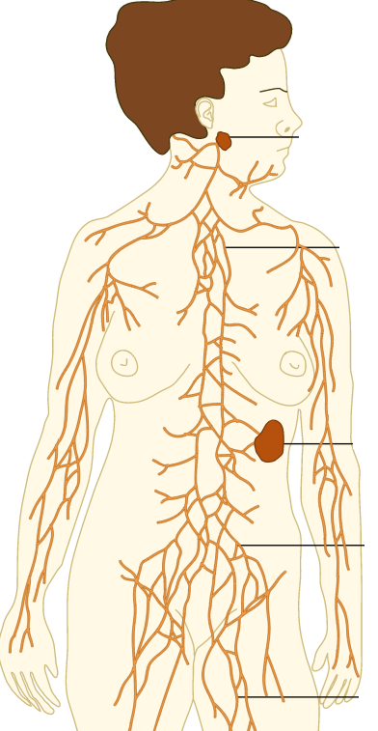

1. What is lymphatic fluid? In your answer state the major components that make up lymphatic fluid.

(3 marks)

|  |  |
| --- | --- |
| Description | Mark |
| A clear/white fluid found in lymphatic vessels | 1 |
| It contains plasma | Any 2  1-2 |
| White blood cells/lymphocytes |
| Proteins and fats (from intestines) |
| Total | 3 |

1. Describe **two** functions of the lymphatic system. (4 marks)

|  |  |
| --- | --- |
| Description | Mark |
| **Any two of the following** | |
| Returns fluid to the bloodstream  That has leaked out due to high pressure at the capillaries | 1-2 |
| Protecting the body from pathogens  By passing fluid through lymph nodes | 1-2 |
| Removes cellular waste/debris  By phagocyte action of white blood cells | 1-2 |
| Total | 4 |

1. The lymphatic system is closely linked with the circulatory system. Contrast these two systems describing **three** differences. (6 marks)

|  |  |
| --- | --- |
| Description | Mark |
| The lymphatic system is a one-way system going from capillaries back to the heart  The circulatory system is a two way system with blood being pumped from the heart and returning to the heart | 1-2 |
| The fluid in the lymphatic system does not contain any red blood cells  The blood in the circulatory system contains red blood cells | 1-2 |
| The circulatory system contains three transport tubes; arteries, veins and capillaries  There is one vessel that transport lymphatic fluid/ they are most similar to veins | 1-2 |
| Total | 6 |

**Question 33 (13 marks)**

The diagram below shows a cross section of the small intestine.

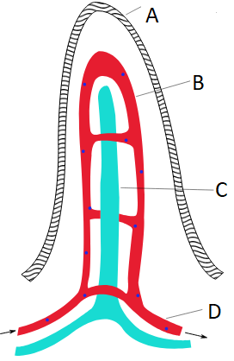

1. Label the structures. (4 marks)

|  |  |
| --- | --- |
| **Description** | **Mark** |
| A- epithelial cells/ lining | 1 |
| B- capillaries/ capillary network | 1 |
| C- lacteal | 1 |
| D- blood vessels | 1 |
| **Total** | **4** |

1. State where in the villus the following nutrients are absorbed. (4 marks)

|  |  |
| --- | --- |
| **Description** | **Mark** |
| Glucose- absorbed into the capillaries | 1 |
| Amino acids- absorbed into the capillaries | 1 |
| Glycerol- absorbed into the lacteal | 1 |
| Fatty acids- absorbed into the lacteal | 1 |
| **Total** | **4** |

1. Describe the ways the structure shown in question 33 on the previous page is suited to its function. (3 marks)

|  |  |
| --- | --- |
| **Description** | **Mark** |
| Thin wall – one cell thick | 1 |
| Large surface Area | 1 |
| Rich supply of blood vessels underneath surface (maintains diffusion gradient etc) |  |
| Presence of microvilli to further increase surface area | 1 |
| **Total (Any 3)** | **3** |

1. Describe how the longitudinal and circular (transverse) muscles move ingested food through the digestive system. (2 marks)

|  |  |
| --- | --- |
| **Description** | **Mark** |
| Peristalsis (must have) | 1 |
| occurs in waves, **or** | 1 |
| circular contracts behind & longitudinal relaxes in front | 1 |
| **Total** | **2** |

**Question 34 (7 marks)**

In 2010, a patient at Westmead hospital in New South Wales, Australia, received the incorrect blood during a transfusion resulting in an ABO incompatibility reaction.

1. Describe how type A and type B blood types differ. (4 marks)

|  |  |
| --- | --- |
| **Description** | **Mark** |
| Type A has A antigens | 1 |
| Type B has B antigens | 1 |
| Type A has B antibodies | 1 |
| Type B has A antibodies | 1 |
| **Total** | **4** |

1. Describe what occurs to the newly transfused blood during an ABO incompatibility reaction. (1 mark)

|  |  |
| --- | --- |
| **Description** | **Mark** |
| Erythrocytes/RBCs agglutinate/clump together/coagulate | 1 |
| **Total** | **1** |

1. Explain why people with O negative type blood are referred to as universal donors.

(2 marks)

|  |  |
| --- | --- |
| **Description** | **Mark** |
| Blood has no A, B or Rh factor antigens on their surface | 1 |
| Doesn’t matter what, if any antibodies recipient has | 1 |
| **Total** | **2** |

**Question 35 (19 marks)**

The diagram below shows an alveolus surrounded by a capillary.

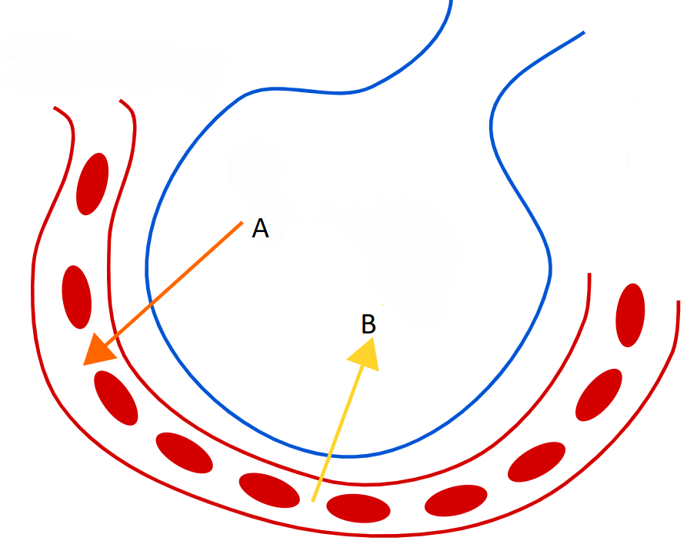

(a) Describe **four (4)** ways in which this structure is well suited to the function of gas exchange. (4 marks)

|  |  |
| --- | --- |
| **Description** | **Mark** |
| Moist surfaces to allow for gases to dissolve | 1 |
| Very thin membrane/ membrane one cell thick | 1 |
| Large SA:V ratio | 1 |
| They are surrounded by a huge network of capillaries | 1 |
| **Total** | **4** |

(b) (i) **Name** gas A. **Oxygen (not O2)** (1 mark)

(ii) Explain how gas A is transported in the blood. (2 marks)

|  |  |
| --- | --- |
| **Description** | **Mark** |
| A small amount is dissolved in the plasma | 1 |
| A large amount is combined with haemoglobin as oxyhaemoglobin | 1 |
| **Total** | **2** |

(c) (i) **Name** gas B. **Carbon dioxide (not CO2)** (1 mark)

(ii) Explain how gas B is transported in the blood. (3 marks)

(3 marks)

|  |  |
| --- | --- |
| Description | Mark |
| A small amount is dissolved in the blood | 1 |
| Slightly more carbon dioxide is to bound to Haemoglobin haemoglobin/carbaminohaemoglobin | 1 |
| The majority is transported as bicarbonate ions | 1 |
| **Total** | **3** |

(d) Explain how efficient exchange of gas A and gas B occurs across the alveolar and capillary membranes. (4 marks)

|  |  |
| --- | --- |
| Description | Mark |
| A high concentration gradient is maintained of oxygen in the lungs and carbon dioxide in the blood | 1 |
| This is because of breathing happing continuously to keep oxygen levels high in the lungs | 1 |
| Blood is continuously pumping which keeps carbon dioxide high in the blood | 1 |
| This allows for continuous diffusion of carbon dioxide into the lungs and oxygen into the blood | 1 |
| **Total** | **4** |

(e) Describe the causes of asthma and the effects that occur in the lungs during an asthma attack. (4 marks)

|  |  |
| --- | --- |
| Description | Mark |
| Many possible triggers eg. dust, pollution, pollen, cold air, others. | 1 |
| Bronchioles narrow | 1 |
| Airways inflamed | 1 |
| Excessive mucous | 1 |
| **Total** | **4** |

Triggers .... 1 mark, Effects .... 3 marks

**Question 36 (8 marks)**

Covid-19 leads to blood clots in an estimated 30% of critically ill patients.

1. Identify the component of blood that is associated with clotting and give a reason why it is important that blood clots. (2 marks)

|  |  |
| --- | --- |
| **Description** | **Mark** |
| Platelets/thrombocytes | 1 |
| One of the following for 1 mark: | |
| * prevent the loss of blood * prevent infection * allow healing | 1 |
| **Total** | **2** |

The inferior view of a heart, which has been dissected horizontally across its short axis, is shown below.

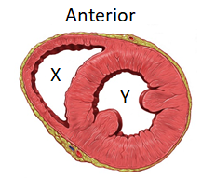

1. Identify the section labelled X and explain why its structure differs to that of the section labelled Y. (3 marks)

|  |  |
| --- | --- |
| **Description** | **Mark** |
| Right ventricle | 1 |
| Requires lower pressure/Only pumps to lungs/does not need to pump around the body | 1 |
| Whereas Y pumps to the entire body/requires higher pressure | 1 |
| **Total** | **3** |

1. Covid-19 has also been shown to cause enlargement of the heart muscles. Describe how this would affect the structure and function of the section labelled Y.

(3 marks)

|  |  |
| --- | --- |
| **Description** | **Mark** |
| decreased lumen/space for blood | 1 |
| reduced pumping ability | 1 |
| less blood pumped around the body | 1 |
| **Total** | **3** |

**Question 37 (14 marks)**

A year 11 Human Biology student was interested to find out how surface area to volume ratio would affect absorption. They made agar cubes that were dyed pink with phenolphthalein. The students made 3 sizes of cube. 5mm, 10mmand 15mm. The student then placed the cubes in an acid solution for 20 minutes. Phenolphthalein turns from pink to clear when it comes into contact with an acid. After 20 minutes the student used a ruler to measure the clear section of the cube which he then converted into a volume.

The results are found below.

|  |  |  |  |  |
| --- | --- | --- | --- | --- |
| Size of cube (mm) | Surface  Area (mm2) | Volume  (mm3) | Surface Area: Volume | Volume of acid absorbed (mm3) |
| 5 | 25 | 125 | 1:5 | 125 |
| 10 | 50 | 1000 | 1:20 | 225 |
| 15 | 90 | 3375 | 2:75 | 250 |

(1 each line)

1. Complete the **Volume** column and **Surface Area:Volume** column in the table above.  
    (3 marks)
2. Propose an appropriate hypothesis for this investigation. (2 marks)

|  |  |
| --- | --- |
| **Description** | **Mark** |
| Any statement that links the independent variable | 1 |
| To the dependant variable | 1 |
| **Total** | **2** |
| Sample answer:  The higher the SA:V the higher percentage of acid is absorbed | |

1. Name the independent and dependant variables for this investigation. (2 marks)

Independent variable:

|  |  |
| --- | --- |
| **Description** | **Mark** |
| SA:V of the cubes | 1 |
| **Total** | **1** |

Dependent variable:

|  |  |
| --- | --- |
| **Description** | **Mark** |
| Absorption of acid | 1 |
| **Total** | **1** |

1. In order to ensure valid results, a number of variables had to be controlled.  
   List **three (3)** of these. (3 marks)

|  |  |
| --- | --- |
| 1. **Description** | **Mark** |
| Same concentration of acid solution | 1-3 |
| Same concentration of phenolphthalein |
| Same time in the acid for all cubes |
| Same method to prepare the cubes |
| Same method to measure the volume of absorbed acid |
| **Total** | **3** |

1. Suggest a conclusion for this experiment regarding Surface Area:Volume and absorption. (2 marks)

|  |  |
| --- | --- |
| **Description** | **Mark** |
| The higher the SA:V ratio | 1 |
| The more efficient absorption of substances | 1 |
| Or vice versa |  |
| **Total** | **2** |

1. The largest cell in the human body is an ovum which is 100µm. Using the information obtained from this experiment, suggest why cells cannot get any larger. (2 marks)

|  |  |
| --- | --- |
| **Description** | **Mark** |
| It the SA:V was too small the cell wouldn’t be able to remove wastes | 1 |
| And absorb nutrients efficiently | 1 |
| **Total** | **2** |

**Question 38 (13 marks)**

The diagram below illustrates a simplified version of an animal cell.

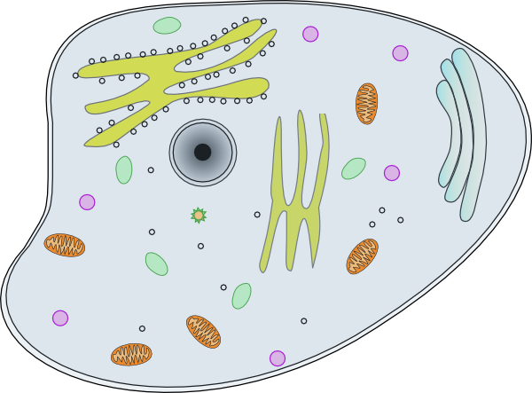

**Lysosome**

**C**

**E**

**B**

**As**

**D**

1. Identify the following organelles from the diagram above: (2 marks)

C: Mitochondria

E: Golgi Body/Complex

1. Describe how Organelle A and Organelle D work together to create lysosomes.

(2 marks)

|  |  |
| --- | --- |
| **Description** | **Mark** |
| Lysosomes are formed in Organelle D/Golgi body/network/apparatus | 1 |
| Enzymes within the lysosome are formed in Organelle A/rough endoplasmic reticulum | 1 |
| **Total** | **2** |

Digestion of proteins occurs in the stomach and small intestine through the activity of pepsin and trypsin enzymes, respectively.

1. Would you expect trypsin to have a higher or lower optimal pH level as compared to pepsin? Give a reason for your answer. (2 marks)

|  |  |
| --- | --- |
| **Description** | **Mark** |
| Higher | 1 |
| Environment of small intestine is less acidic/more alkaline  OR  does not contain hydrochloric acid like stomach | 1 |
| **Total** | **2** |

1. Enzymes are specific to certain molecules. Draw a labelled diagram to illustrate the lock and key model during an anabolic reaction. (4 marks)

|  |  |
| --- | --- |
| **Description** | **Mark** |
| Two substrates (both labelled) become one product (labelled) | 1 |
| Enzymes active site labelled AND matches substrate/s shape | 1 |
| Enzyme-substrate complex labelled | 1 |
| Resulting enzyme shows no change | 1 |
| Example: | |
|  | |
| **Total** | **4** |

The enzyme catalase breaks down hydrogen peroxide (H2O2) to form water and oxygen. The reaction rate can be calculated by measuring the height of bubbles formed per second. The incomplete graph below shows the results of an experiment that investigated the effect of substrate concentration in percentage on the activity of catalase.

1. Identify the saturation point for catalase in this experiment and describe how enzyme function is affected once saturation point is achieved. (3 marks)

|  |  |
| --- | --- |
| **Description** | **Mark** |
| 80% | 1 |
| All available enzymes are working at their maximum rate | 1 |
| Any substrate increase has no effect on rate of reaction | 1 |
| **Total** | **3** |

**End of Section Two**

**Section Three: Extended answer 20% (40 Marks)**

This section contains **three (3)** questions. You must answer **two (2)** questions. Make sure you clearly indicate which question you are answering and write your answers in the space provided.

Use black or blue pen for this section. Only graphs and diagrams may be drawn in pencil. Responses can include: labelled diagrams with explanatory notes; lists of points with linking sentences; labelled tables and/or graphs; and/or annotated flow diagrams with introductory notes.

Supplementary pages for planning/continuing your answers to questions are provided at the end of this Question/Answer booklet. If you use these pages to continue an answer, indicate at the original answer where the answer is continued, i.e. give the page number.

Suggested working time: 40 minutes.

**Question 38 (20 marks)**

1. Water is a waste product that is produced by metabolism. Humans also take in water every day to ensure correct concentration.

Describe the three ways water is lost from the body. In your description name the organ give details about the process. (9 marks)

|  |  |
| --- | --- |
| **Description** | **Mark** |
|  | |
| Sweat/Sweating | 1 |
| Sweating via sweat glands in/on skin | 1111112 |
| Water used in the regulation of body temperature | 1 |
|  | |
| Urination | Any 3 |
| Urine is composed mainly of water |
| Used to dilute urea which is toxic in high concentrations |
| Urine forms in kidneys, stored in bladder & voided via. urethra |
|  | |
| Breathing (not respiration) | 1 |
| Internal structures of lungs kept moist to assist with gas exchange | 1 |
| Air warmed when inhaling causes evaporation of water inside lungs which is lost when exhaling | 1 |
| **Total** | **9** |

1. Describe the processes of filtration, secretion and reabsorption in the nephron   
    (11 marks)

|  |  |
| --- | --- |
| **Description** | **Mark** |
| Filtration | |
| Takes place in renal capsule | 1 |
| Unfiltered blood passes into glomerulus | 1 |
| High pressure forces water and most blood components (not r.b.c’s or plasma proteins) into Bowman’s capsule | 1 |
| Fluid that passes into Bowman’s capsule is called filtrate | 1 |
| Reabsorption | |
| Most reabsorption happens in Proximal Convoluted Tubule | 1 |
| Glucose, Amino-acids, Ions and some water | 1 |
| are selectively reabsorbed | 1 |
| Most water is reabsorbed actively with a process called facultative reabsorption | 1 |
| Secretion | |
| Occurs in the Distal Convoluted Tubule | 1 |
| Materials move from the blood into the filtrate | 1 |
| Materials that are secreted are H+, K+, certain drugs, creatinine | 1 |
| **Total** | **11** |

**Question 39 (20 marks)**

1. There are six main methods in which materials are transported across cell membranes.

Describe how four (4) of these methods occur, the type of material that is transferred

and a specific example of where it occurs in the body.

(12 marks)

*Any 4 methods, 3 marks each.*

|  |  |  |  |
| --- | --- | --- | --- |
| **Method** | **How method occurs** | **Body part** | **Type of material** |
| Diffusion | * Liquid/gas particles randomly move from an area of high to low concentration. * Particles keep moving until they have evenly spaced themselves out in the available area.   (1 mark) | * PCT and Loop of Henle of kidneys. * Alveoli of lungs * Villi of small intestine * Mouth and Stomach wall * Large intestine   (1 mark) | * Oxygen and carbon dioxide. * Alcohol * Fat soluble vitamins.   (1 mark) |
| Facilitated diffusion | * Particles move from an area of high to low concentration THROUGH a carrier protein. * Particle binds to carrier protein, protein changes shape and moves particle to other side.   (1 mark) | * Kidneys * Small intestines, * Liver   (1 mark) | * Substances that are too large to fit through the plasma membrane, such as glucose / amino acids.   (1 mark) |
| Osmosis | * The movement of a solvent (usually water) from an area of high to low concentration THROUGH a semi-permeable membrane.   (1 mark) | * Kidney nephrons and small intestines. * All cells of the body. * Large intestines * Stomach wall   (1 mark) | * Water.   (1 mark) |
| Active transport | * Liquid/gas particles move from an area of low to high concentration across the cell membrane. * Large molecules are taken across the cell membrane via carrier proteins   (1 mark) | * PCT * Small intestine/villi * Kidneys * Small intestines, * Liver * Fat soluble molecules through any cell membrane.   (1 mark) | * Glucose * Amino acids * Na+ / K+ * Steroids * Some vitamins.   (1 mark) |
| Endocytosis | * When a cell surrounds some extracellular material with a fold of the cell membrane. * The enfolding membrane then breaks away, and the material is enclosed within the cell in the form of a small membrane-bound vesicle. * Two types, phagocytosis (solid engulfing) and pinocytosis (liquid engulfing).   (1 mark) | * White blood cells/leucocytes. * All cells carry out pinocytosis, therefore any organ.   (1 mark) | * Pathogens * Any liquid.   (1 mark) |
| Exocytosis | * When the contents of a vesicle are pushed out through the cell membrane. * The membrane around the vesicle fuses with the cell membrane and the vesicle contents are passed to the exterior.   (1 mark) | * Mammary glands. * Saliva glands * Pancreas * Liver * Gastric pits. * Hormonal /endocrine gland.   (1 mark) | * Milk * Saliva * Digestive enzymes * Hormones   (1 mark) |

|  |
| --- |
| (b) Describe the mechanism by which air is drawn into and forced out of the lungs  during normal breathing. (8 marks) |
|  |

|  |  |
| --- | --- |
| **Description** | **Mark** |
| The two processes that drive this process are inspiration  and expiration | 1-2 |
| Inspiration | |
| Intercostals & diaphragm muscles contract pulling ribcage up/out  This decreases the pressure /increases the volume of the thoracic cavity  Air flows in from high pressure area outside the body to low pressure thoracic cavity | 1-3 |
| Expiration | |
| Intercostals & diaphragm muscles relax moving ribcage down/in  This increases the pressure /decreases the volume of the thoracic cavity  Air flows in from high pressure thoracic cavity to low pressure area outside the body | 1-3 |
| **Total** | **8** |

**Question 40 (20 marks)**

1. The normal heart rate for a healthy adult at rest is 60 to 70 beats per minute. Irregular heartbeats, such as during a heart attack, can affect the flow of blood through the heart and may even result in death.

Describe how blood normally flows through the heart and explain the effect on blood flow in the heart if the valve between the left atrium and ventricle was ineffective. (10 marks)

|  |  |
| --- | --- |
| **Description** | **Mark** |
| Any 8 of the following for 1 mark each. Max 6 if not in the correct order. | |
| Blood enters the right atrium | 1-8 |
| through the vena cava/superior and inferior vena cava |
| Blood flows through tricuspid valve |
| Into the right ventricle |
| Past the pulmonic valve/semilunar valve |
| into pulmonary artery |
| Oxygenated blood returns via pulmonary veins |
| Into the left atrium |
| Through the mitral valve/biscupid |
| Into the left ventricle |
| Past the aortic valve/semilunar valve |
| Into the aorta |
|  | |
| Blood flows backwards / blood would flow from ventricle to atrium | 1 |
| Less oxygenated blood would flow to the body | 1 |
| **Total** | **10** |

1. The system of vessels which distributes blood around the body is made up of THREE different types of vessels: arteries, veins and capillaries. Explain the difference in structure and function of each of these vessels. (10 marks)

|  |  |
| --- | --- |
| **Description** | **Mark** |
| Arteries | |
| **Structure**  Thick muscular walls  elastic fibres  narrow lumen | 1-3 |
| **Function**  Walls stretch/expand to deal with high pressure blood coming from the heart/ vasodilation and contraction/ take blood to the body | 1 |
| Veins | |
| **Structure**  Thinner walls than arteries  No/few elastic fibres  Large/irregular shaped lumen  Contains valves | 1-3 |
| **Function**  Returns blood to the heart/ valves prevent blood from pooling/skeletal muscle movement returns blood to the heart | 1 |
| Capillaries | |
| **Structure**  One cell thick/ very thin walls | 1 |
| **Function**  Site of gas exchange from blood to tissues | 1 |
| **Total** | **10** |

**End of Questions**